

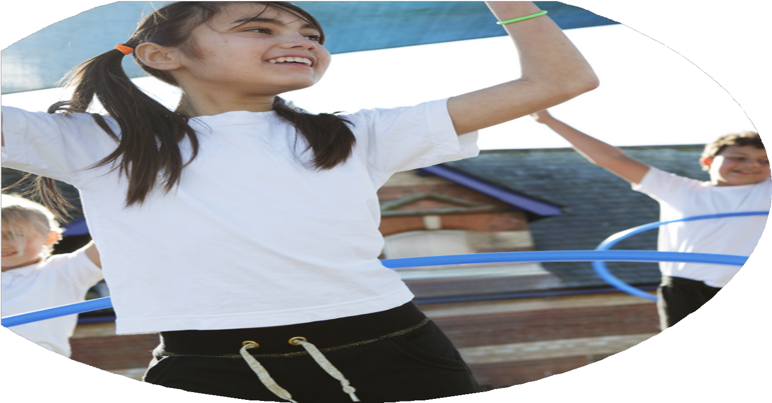
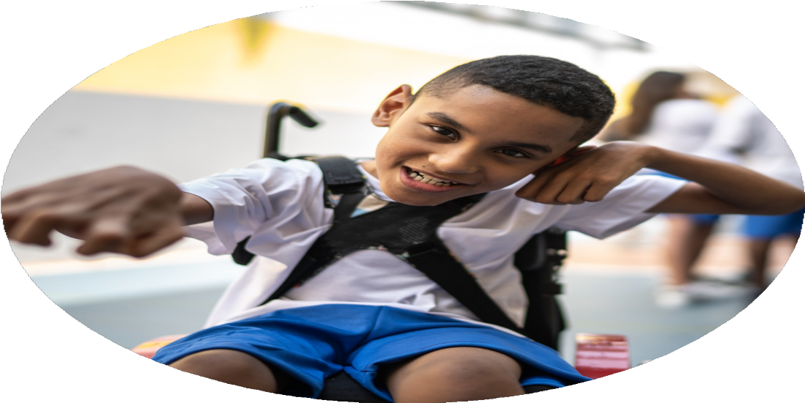
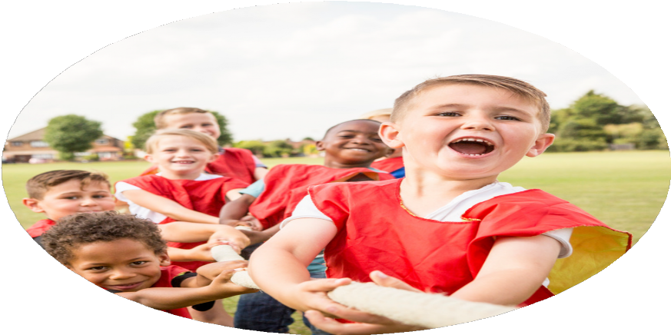



The Primary PE

and Sport Premium
Planning, reporting and evaluating website tool

Commissioned by

Created by S Beckett

Images courtesy of Youth Sport Trust

PE Funding Evaluation Form

It is intended that this template should be used as preparation for the completion of the statutory digital reporting tool being introduced this academic year. You can upload data (including swimming) from this template onto this platform once it becomes accessible.
Before you decide how you are going to use the funding for this academic year you should reflect and evaluate the impact of your use of the funding in 2023/24.
All spending of the funding must conform with the terms outlined in the Conditions of Grant document. The template is a working document that you can amend/update during the year.
Based on your evaluation of last year’s funding you should decide what you intend to do this academic year, how you will do it, and what impact you expect it to have.

It is important that the funding is used effectively and based on your school’s needs.
You must use the funding to make additional and sustainable improvements to the PE and sport in your school. You must develop and add to the PESSPA activities that your school already offers.

Summative digital reporting from June 2025 will continue to include swimming and water safety information therefore funding can be used to provide top-up lessons where necessary to ensure pupils meet national curriculum swimming requirements.

We recommend that you start by reflecting on the impact of current provision and reviewing your previous spend.
What went well?
How do you know?
What didn’t go well?
How do you know?

-Higher levels of confidence and competence from staff. Lessons are more active.

- Positive experiences offered to children. A wide range of festivals and competitions offered. New activities engaged children.

- Higher numbers of children engaged in active travel training. More children travelling to school actively.

-Children enjoyed the training and liked the responsibility of being sports leaders.

-Children can demonstrate the values talked about.
- Staff not always confident that lesson plans matched objectives and offered enough support.

Not enough time/staff to organize and maintain the timetable.

Not enough time/staff to organize and maintain the timetable.

-Use of ‘custom units’. Not provided by Complete PE.

Offering regular ‘walking buses’ for children to walk to school with teachers

-Sports leaders were not given enough support throughout the year.
1 Complete PE/Teach Active subscriptions for use by all staff

2. Festivals and competitions

3. Active Travel in school

4. Sports Leadership Training

5.Use of ‘My Personal Best’ to promote life skills using the MPB values in all aspects of the school day.

What are your plans for 2024/25

Intent
How are you going to action and achieve these plans?

Implementation
- Increase physically active minutes throughout the school day.

- Children to participate in some form of sport or physical activity in addition to their active minutes/PE lessons in school.

- Develop the areas in EYFS to aid gross and fine motor skills and to promote the ‘My Personal Best’ statements to develop social/life skills.

1.Complete PE and Teach Active renewal.
CPD for staff needs. RESSP CPD and Team Teach.
Playground leaders/Sports Leader training. Establish rotas for leaders.
Staff allocated to leaders.
Storage for playground equipment.
Creating Active School scheme – TVS and RESSP
Active Travel schemes – Pedestrian Training, Balance Training, Learn to Ride, Bikeability, Living Streets Travel Tracker.
Increase after school clubs offer.

2. Attend festivals and competitions offered by RESSP/with other schools.
Increase after school clubs offer.
Use celebration assemblies as an opportunity to promote different sports/activities and hobbies.
Make connections with external providers.

3. Identify needs.
Provide equipment and resources to develop skills.
CPD for staff
Begin to adapt planning to meet physical needs.
RESSP to complete ‘Motor Screening’ with Reception children (After Feb 2025)
Interventions to be completed weekly.
RESSP to re-screen at the end of the year.

What impact/intended impact/sustainability are you
expecting?
How will you know? What evidence do you have or
expect to have?

Children will be more active during break and lunchtimes and will be engaged in fun activities which are designed to support movement/develop skills, thus contributing to positive experiences.
Sports Leaders will be more confident and more willing to offer a wider variety of activities. They will have more children engaged in activities.
Travel trackers will show an increase in active travel to school which will be maintained across the school year.
Staff will complete the self-review tool.

Pupil voice – will show attitudes about PESPA have improved.
Increase in number of after school clubs offered – registers/participation tracker will show an increase in activity.

KS1 Teachers will report an increase in competence and confidence in children moving up from EYFS.
Pupil Assessment will show objectives are being met.
1.Children will be more engaged in physical activity throughout the school day.
Children will be more excited to try new opportunities.
Children will be more likely to encourage others to join in with /try different activities.
Sports Leaders will improve their confidence and competence, making break and lunchtimes more active.
More children will travel to school actively.
Build connections with external providers for after school clubs.
Children understand how to use and look after equipment – MPB values will help with this.
Staff will be confident to teach active lessons and know how to support all children in and out of the classroom.

2. Children will be more excited to try new opportunities.
Children will be more likely to encourage others to join in with /try different activities.
Children will attend festivals/competitions/after school clubs.

3.Early Years children are confident and competent movers.
Early Years team observe and learn from RESSP and deliver weekly interventions to children identified so they are competent moving into KS1.
Planning and interventions are adapted to meet the needs of each cohort using training from RESSP.

What impact/sustainability have you seen?

What evidence do you have?

Increased pupil participation in physical activity (after school clubs, competitions, festivals) Tracking document to show participation in physical activity outside of the normal school day.
Events offered are differentiated – competition/developmental. This means more children
are offered a positive experience and are more likely to enjoy the activity they are attending.
They are more likely to maintain participation in the activity/sport.

An increase in active minutes during the school day – using playground and sports leaders, Data is gathered which shows number of children travelling actively during the school week/
Teach Active, active travel schemes, active travel training. children who take part in active travel schemes in school – pedestrian training, balance bikes,
Learn to Ride, Bikeabililty.
Positive experience with a competitive element for the active travel element – children are
more determined to travel actively to ‘beat’ other classes in school.

Children are more likely to try new activities – after-school clubs have been matched to Pupil voice/tracking document used.
children’s requests.
Links are made with local clubs to encourage children to maintain participation.

Reception children have made progress using the screening tool and interventions Spreadsheet used by staff to highlight needs and guide them towards appropriate interventions.
Gaps narrowed or closed using interventions/activities in the areas.
Screening programme booked for 2025 26

